Technical Certification Program
MAY 2026 Course Brochure
2025-2026 Season

PROGRAM INFORMATION
Use the MnDOT Technical Certification Program website mndot.gov/technical-certification to:
- Find your course materials
- Get logistics about classes, such as what to bring or wear
- See cancellation and rescheduling policies and directions
- Get step-by-step directions for registering for classes
- Access your Tech ID and Technical Certification card
- Learn about the certification process
- Take your exam and find procedures for retests and test-outs
- Find construction resources and MnDOT contacts

CERTIFICATION FLOW CHART
Some courses have prerequisites. We highly recommend you complete them in order. This step-by-step approach helps you build a strong foundation, making it easier for both new and experienced learners to follow the material and succeed in advanced courses.
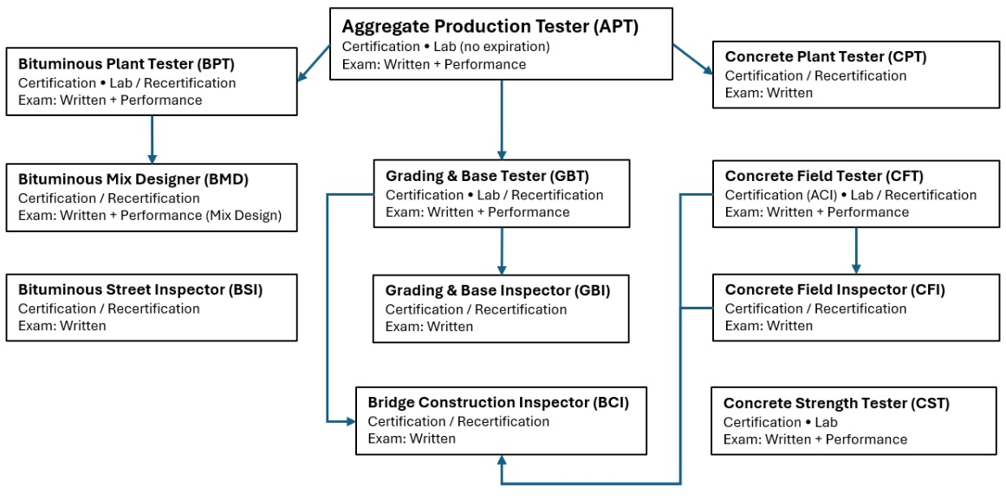

WAITING LISTS
If a class you want is full, use the Waiting List. There is no charge to get on a Waiting List. Payment is due only once you are registered in a class. Also then register for an open class date/location that you could attend, even though not your first choice. If you get a spot in the Waiting List class, we will move your registration to the wait listed class.

ACCOMMODATIONS
Individuals who have a disability, either permanent or temporary, which might affect their ability to perform in a class, should contact Lake Superior College (LSC) for accommodation.

SAFETY SHOE REQUIREMENT
All individuals attending certification classes with lab session are required to wear safety toed shoes in the lab or they will not be allowed to participate in that lab session. This means certification will not be granted, even with a passing exam score, until all lab requirements have been successfully completed in compliance with lab safety regulations.

RECERTIFICATION
If any of your certifications show an expiration date of 05/31/2026, you must complete a recertification class this training season to retain certification in that area. If your certification has expired, you must successfully complete the original certification course, including any performance evaluations. For more information contact the Technical Certification Program. Email: tech-cert.dot@state.mn.us

PROGRAM CONTACT
MnDOT
Email: tech-cert.dot@state.mn.us
Website: mndot.gov/technical-certification
All class times are 8:00 am – 4:30 pm (exception: BCIC)

REGISTRATION CONTACTS
Lake Superior College
Iris Hiemenz
218.733.1023
Iris.hiemenz@lsc.edu

Suzanne Johnsrud
218.428.1002
Suzanne.johnsrud@lsc.edu

Register for a class

Minnesota State College Credits
You can obtain college credits through Lake Superior College (LSC). You must complete an LSC course credit form which will be sent to you after the class is over.

Concrete Field Tester

Concrete Field Tester Certification – Course Schedule
ID # | Date | Location
CFTC-053 | May 7, 2026 – May 8, 2026 | TCC - Maplewood
CFTC-054 | May 14, 2026 – May 15, 2026 | TCC - Maplewood
CFTC-055 | May 21, 2026 – May 22, 2026 | TCC - Maplewood

Course Details
- Prerequisites: None
- Days: 2
- Cost: $625
- Lab: Yes
- Personal Protective Equipment (PPE): Steel-toed shoes (required)
- Exams: Written (ACI exam, following ACI procedures) and Performance (ACI hands-on exam, following ACI procedures)
- Professional Development Hours (PDH): 12
- Minnesota State College Credits: 1

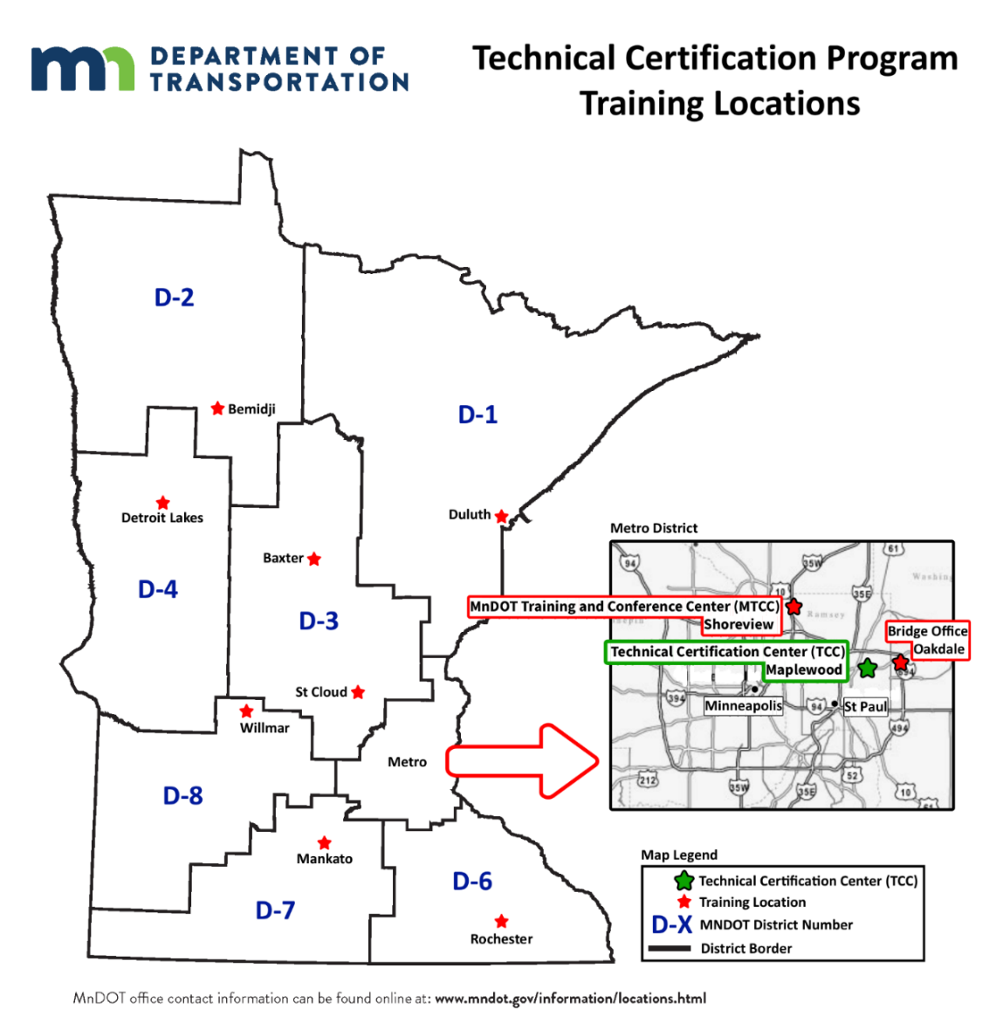

Metro: Technical Certification Center (TCC)  (Front entrance with blue roof)  Office of Materials and Road Research  1400 Gervais Ave  Maplewood, MN 55109  Metro: Maplewood Lab  (Front entrance between flagpoles)  Office of Materials and Road Research  1400 Gervais Ave  Maplewood, MN 55109  District 1: Duluth  1123 Mesaba Ave  Duluth, MN 55811  District 2: Bemidji  3920 US-2  Bemidji, MN 56601  District 3: Baxter  7694 Industrial Park Rd S  Baxter, MN 56425  District 3: St. Cloud  3725 12th St N  St. Cloud, MN 56303 | Metro: MnDOT Training and Conference Center (MTCC)  1900 County Rd I  Shoreview, MN 55126  Bridge Office – Oakdale  3485 Hadley Avenue North  Oakdale, MN 55128  District 4: Detroit Lakes  1000 US-10  Detroit Lakes, MN 56501  District 6: Rochester  2900 48th St NW  Rochester, MN 55901  District 7: Mankato  2151 Bassett Dr  Mankato, MN 56001  District 8: Willmar  2505 Transportation Rd  Willmar, MN 56201

