


Technical Certification Program
2025-2026 Season

MARCH 2026 Course Brochure

PROGRAM INFORMATION
Use the MnDOT Technical Certification Program website mndot.gov/technical-certification to:
- Find your course materials
- Get logistics about classes, such as what to bring or wear
- See cancellation and rescheduling policies and directions
- Get step-by-step directions for registering for classes
- Access your Tech ID and Technical Certification card
- Learn about the certification process
- Take your exam and find procedures for retests and test-outs
- Find construction resources and MnDOT contacts

CERTIFICATION FLOW CHART
Some courses have prerequisites. We highly recommend you complete them in order. This step-by-step approach helps you build a strong foundation, making it easier for both new and experienced learners to follow the material and succeed in advanced courses.
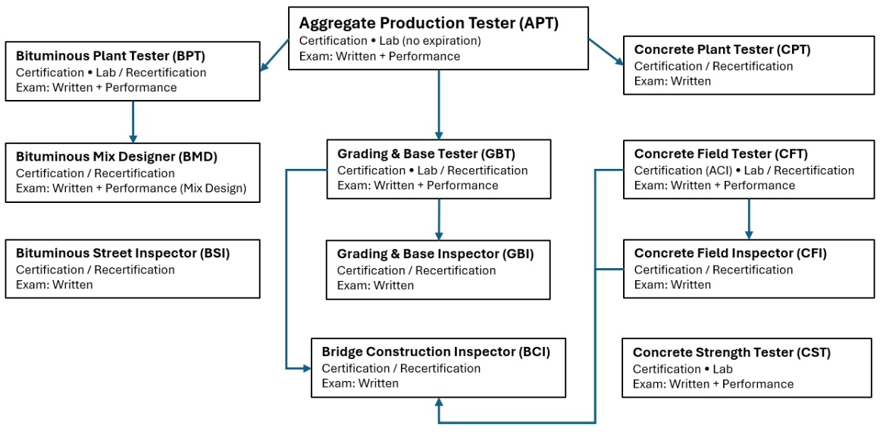

WAITING LISTS
If a class you want is full, use the Waiting List. There is no charge to get on a Waiting List. Payment is due only once you are registered in a class. Also then register for an open class date/location that you could attend, even though not your first choice. If you get a spot in the Waiting List class, we will move your registration to the wait listed class.

ACCOMODATIONS
Individuals who have a disability, either permanent or temporary, which might affect their ability to perform in a class, should contact Lake Superior College (LSC) for accommodations.

SAFETY SHOE REQUIREMENT New!
All individuals attending certification classes with lab session are required to wear safety toed shoes in the lab or they will not be allowed to participate in that lab session. This means certification will not be granted, even with a passing exam score, until all lab requirements have been successfully completed in compliance with lab safety regulations.

RECERTIFICATION
If any of your certifications show an expiration date of 05/31/2026, you must complete a recertification class this training season to retain certification in that area. If your certification has expired, you must successfully complete the original certification course, including any performance evaluations. For more information contact the Technical Certification Program. Email: tech-cert.dot@state.mn.us

PROGRAM CONTACT
MnDOT
Email: tech-cert.dot@state.mn.us
Website: mndot.gov/technical-certification
All class times are 8:00 am – 4:30 pm (exception: BCIC)

REGISTRATION CONTACTS
Lake Superior College
Iris Hiemenz
218.733.1023
Iris.hiemenz@lsc.edu

Suzanne Johnsrud
218.428.1002
Suzanne.johnsrud@lsc.edu

Register for a class

Minnesota State College Credits
You can obtain college credits through Lake Superior College (LSC). You must complete an LSC course credit form which will be sent to you after the class is over.

Aggregate Production Tester

Aggregate Production Tester Certification (APTC)  ID# DATES LOCATION  APTC-128 11/18/25 - 11/20/25 D-3 St Cloud  APTC-129 11/19/25 - 11/21/25 D-3 St Cloud  APTC-130 12/09/25 - 12/11/25 Maplewood Lab  APTC-131 12/10/25 - 12/12/25 Maplewood Lab  APTC-132 12/16/25 - 12/18/25 Maplewood Lab  APTC-133 12/17/25 - 12/19/25 Maplewood Lab  APTC-134 01/06/26 - 01/08/26 D-1 Duluth  APTC-135 01/07/26 - 01/09/26 D-1 Duluth  APTC-136 01/13/26 - 01/15/26 D-7 Mankato  APTC-137 01/14/26 - 01/16/26 D-7 Mankato  APTC-138 01/20/26 - 01/22/26 D-6 Rochester  APTC-139 01/21/26 - 01/23/26 D-6 Rochester  APTC-140 01/27/26 - 01/29/26 D-8 Willmar  APTC-141 01/28/26 - 01/30/26 D-8 Willmar  APTC-142 02/03/26 - 02/05/26 D-2 Bemidji  APTC-143 02/04/26 - 02/06/26 D-2 Bemidji  APTC-144 02/10/26 - 02/12/26 TCC - Maplewood  APTC-145 02/11/26 - 02/13/26 TCC - Maplewood  APTC-146 02/24/26 - 02/26/26 D-6 Rochester  APTC-147 02/25/26 - 02/27/26 D-6 Rochester  APTC-148 03/10/26 - 03/12/26 TCC - Maplewood  APTC-149 03/11/26 - 03/13/26 TCC – Maplewood  APTC-150 03/17/26 - 03/19/26 D-8 Willmar  APTC-151 03/18/26 - 03/20/26 D-8 Willmar  APTC-154 03/31/26 - 04/02/26 TCC - Maplewood | PREREQUISITES: NONE  DAYS: 3  COST: $500  LAB: Yes  Personal Protective Equipment (PPE):  - Steel toed shoes REQUIRED  EXAM(S):  - Written  - Performance (hands-on)  Professional Development Hours (PDH): 18  Minnesota State College Credits: 1  TAKE THIS COURSE FIRST:  This certification is a prerequisite for many other courses and provides an important introduction to roadway construction and materials testing.

Bituminous Plant Tester

Bituminous Plant Tester Certification (BPTC)  ID# DATES LOCATION  BPTC-041 01/20/26 - 01/22/26 Maplewood Lab  BPTC-042 01/21/26 - 01/23/26 Maplewood Lab  BPTC-043 01/27/26 - 01/29/26 D-6 Rochester  BPTC-044 01/28/26 - 01/30/26 D-6 Rochester  BPTC-045 02/24/26 - 02/26/26 D-3 Baxter  BPTC-046 02/25/26 - 02/27/26 D-3 Baxter  BPTC-047 03/10/26 - 03/12/26 D-1 Duluth  BPTC-048 03/11/26 - 03/13/26 D-1 Duluth | PREREQUISITES:  - Aggregate Production Tester (APTC)  DAYS: 3  COST: $500  LAB: Yes  Personal Protective Equipment (PPE):  - Steel toed shoes REQUIRED  EXAM(S):  - Written  - Performance (hands-on; done in District lab after the class is completed)  Professional Development Hours (PDH): 18  Minnesota State College Credits: 1

Bituminous Plant Tester Recertification (BPTR)  ID# DATES LOCATION  BPTR-019 01/13/26 D-6 Rochester  BPTR-020 02/09/26 TCC - Maplewood  BPTR-021 02/17/26 TCC – Maplewood  BPTR-022 04/02/26 D-1 Duluth | PREREQUISITES: Current BPTC  DAYS: 1  COST: $250  LAB: No  Personal Protective Equipment (PPE):  - None  EXAM(S):  - Written  Professional Development Hours (PDH): 6  Minnesota State College Credits: 0

BITUMINOUS
Bituminous Mix Design

Bituminous Mix Designer Certification (BMDC)  ID# DATES LOCATION  BMDC-013 02/02/26 - 02/05/26 TCC - Maplewood | PREREQUISITES:  - Aggregate Production Tester (APTC)  - Bituminous Plant Tester (BPTC)  DAYS: 4  COST: $575  LAB: Yes  Personal Protective Equipment (PPE):  - Steel toed shoes REQUIRED for lab visit days  EXAM(S):  - Written  - Performance (Mix Design Submittal)  Professional Development Hours (PDH): 24  Minnesota State College Credits: 2

Bituminous Mix Designer Recertification (BMDR)  ID# DATES LOCATION  BMDR-008 02/10/26 Virtual  BMDR-009 03/05/26 Virtual | PREREQUISITES: Current BMDC  DAYS: 1  COST: $250  LAB: No  Personal Protective Equipment (PPE):  - None  EXAM(S):  - Written  Professional Development Hours (PDH): 6  Minnesota State College Credits: 0

Bituminous Street Inspector

Bituminous Street Inspector Certification (BSIC)  ID# DATES LOCATION  BSIC-036 12/01/25 - 12/03/25 Virtual  BSIC-037 12/15/25 - 12/17/25 Virtual  BSIC-038 12/17/25 - 12/19/25 Virtual  BSIC-039 01/07/26 - 01/09/26 Virtual  BSIC-040 02/11/26 - 02/13/26 Virtual  BSIC-041 03/18/26 - 03/20/26 Virtual  BSIC-042 04/06/26 - 04/08/26 Virtual  BSIC-043 04/08/26 - 04/10/26 Virtual | PREREQUISITES: None  DAYS: 3  COST: $575  LAB: No  Personal Protective Equipment (PPE):  - None  EXAM(S):  - Written  Professional Development Hours (PDH): 18  Minnesota State College Credits: 1

Bituminous Street Inspector Recertification (BSIR)  ID# DATES LOCATION  BSIR-029 01/08/26 Virtual  BSIR-030 01/13/26 Virtual  BSIR-031 01/15/26 MTCC - Shoreview  BSIR-032 01/22/26 Virtual  BSIR-033 02/03/26 Virtual  BSIR-034 11/01/25 – 05/01/26 E-Learning | PREREQUISITES: Current BSIC  DAYS: 1  COST: $250  LAB: No  Personal Protective Equipment (PPE):  - None  EXAM(S):  - Written  Professional Development Hours (PDH): 6  Minnesota State College Credits: 0

Bridge Construction Inspector

Bridge Construction Inspector Certification (BCIC)  ID# DATES LOCATION  BCIC-013 01/26/26 - 02/06/26 Oakdale Bridge Office  BCIC-014 02/23/26 - 03/06/26 Oakdale Bridge Office  See the BCIC Course Materials page on the MnDOT Technical Certification Program website for list of prerequisites and required online training modules. Class times are 8:00 am - 4:30 pm, with the exception of Monday and Friday. See the BCIC Course Materials web page and the agenda for details.  All online prerequisites must be completed and certificates submitted to Lake Superior College at least two weeks prior to the first day of the bridge class or you will not be allowed to attend. Contact Lake Superior College staff with any questions.  MnDOT employees: you receive access to the ATTS eLearning courses through our state membership.  Employees of other government agencies: If you are registered for the class, you will receive a promotional code to pay for four of the ATTS eLearning courses. Reinforcing Steel for Structures is not eligible. The code will be sent to you by mid-November at the latest. | PREREQUISITES:  - Aggregate Production Tester (APTC)  - Concrete Field Tester (CFTC)  - Concrete Field Inspector (CFIC)  - Grading and Base Tester (GBTC)  - MnDOT and AASHTO TTS online classes (see note)  DAYS: 10  COST: $1,500  LAB: No  Personal Protective Equipment (PPE):  - None  EXAM(S):  - Written (one each week; must past both to pass the class)  Professional Development Hours  (PDH): 60  Minnesota State College Credits: 7

Bridge Construction Inspector Recertification (BCIR)  ID# DATES LOCATION  BCIR-016 01/21/26 MTCC - Shoreview  BCIR-017 02/11/26 Virtual  BCIR-018 03/16/26 MTCC - Shoreview | PREREQUISITES:  - Current BCIC  - All prerequisite certifications with expiration dates (GBTC, CFTC, and CFIC) must also still be current. This means that if they are expired your BCI is expired.  DAYS: 1  COST: $250  LAB: No  Personal Protective Equipment (PPE):  - None  EXAM(S):  - Written  Professional Development Hours  (PDH): 6  Minnesota State College Credits: 0

Concrete Field Tester

Concrete Field Tester Certification - ACI (CFTC)  ID# DATES LOCATION  CFTC-045 12/11/25 - 12/12/25 TCC - Maplewood  CFTC-046 01/08/26 - 01/09/26 TCC - Maplewood  CFTC-047 01/15/26 - 01/16/26 D-1 Duluth  CFTC-048 01/29/26 - 01/30/26 TCC - Maplewood  CFTC-049 02/12/26 - 02/13/26 D-6 Rochester  CFTC-050 03/12/26 - 03/13/26 TCC - Maplewood  CFTC-051 03/26/26 - 03/27/26 TCC - Maplewood  CFTC-052 04/23/26 - 04/24/26 D-7 Mankato  CFTC-053 05/07/26 - 05/08/26 TCC - Maplewood  CFTC-054 05/14/26 - 05/15/26 TCC - Maplewood  CFTC-055 05/21/26 - 05/22/26 TCC - Maplewood | PREREQUISITES: None  DAYS: 2  COST: $625  LAB: Yes  Personal Protective Equipment (PPE):  - Steel toed shoes (REQUIRED)  EXAM(S):  - Written (ACI exam, following ACI procedures)  - Performance (ACI hands-on; following ACI procedures)  Professional Development Hours  (PDH): 12  Minnesota State College Credits: 1

Concrete Field Tester Recertification (CFTR)  ID# DATES LOCATION  CFTR-020 11/01/25 – 05/01/26 eLearning  If only a MnDOT certification is needed or desired, you may take this MnDOT recertification class.  If you need ACI certification, you must repeat and pass the MnDOT 2-day Concrete Field tester (ACI) Certification course or complete the ACI Concrete Field-Testing Technician Grade 1 certification.  See the MnDOT Technical Certification Program website for details or contact TCP staff if you have questions. | PREREQUISITES: Current CFTC  DAYS: 1  COST: $250  LAB: No  Personal Protective Equipment (PPE):  - None  EXAM(S):  - Written  Professional Development Hours  (PDH): 6  Minnesota State College Credits: 0

Concrete Field Inspector

Concrete Field Inspector Certification (CFIC)  ID# DATES LOCATION  CFIC-026 01/12/26 - 01/14/26 MTCC - Shoreview  CFIC-027 01/26/26 - 01/28/26 D-3 St Cloud  CFIC-028 02/24/26 - 02/26/26 MTCC - Shoreview  CFIC-029 03/24/26 - 03/26/26 MTCC - Shoreview  CFIC-030 04/07/26 - 04/09/26 MTCC - Shoreview  CFIC-031 04/28/26 - 04/30/26 MTCC - Shoreview | PREREQUISITES:  - Concrete Field Tester (CFTC)  DAYS: 2.5  COST: $575  LAB: No  Personal Protective Equipment (PPE):  - None  EXAM(S):  - Written  Professional Development Hours (PDH): 15  Minnesota State College Credits: 2

Concrete Field Inspector Recertification (CFIR)  ID# DATES LOCATION  CFIR-030 12/09/25 Virtual  CFIR-031 12/16/25 Virtual  CFIR-032 01/20/26 Virtual  CFIR-033 02/10/26 Virtual  CFIR-034 02/17/26 Virtual  CFIR-035 03/17/26 Virtual  CFIR-036 04/14/26 Virtual  Take this class if you need to recertify in both Concrete Field Inspector and Concrete Field Tester (MnDOT only – not ACI).  If you need ACI Concrete Field Testing Technician Grade 1 certification, retake the full ACI Concrete Field Tester initial certification class, in addition to this Inspector Recertification.  If you only need a MnDOT Concrete Field Tester certification (not ACI and not Inspector), take the Concrete Field Tester Recertification eLearning (see prior page). | PREREQUISITES: Current CFIC  DAYS: 1  COST: $250  LAB: No  Personal Protective Equipment (PPE):  - None  EXAM(S):  - Written  Professional Development Hours (PDH): 6  Minnesota State College Credits: 0

Concrete Plant Tester

Concrete Plant Tester Certification (CPTC)  ID# DATES LOCATION  CPTC-028 01/13/26 - 01/14/26 MTCC - Shoreview  CPTC-029 01/27/26 - 01/28/26 D-7 Mankato  CPTC-030 02/10/26 - 02/11/26 D-3 St Cloud  CPTC-031 03/03/26 - 03/04/26 MTCC - Shoreview  CPTC-032 03/17/26 - 03/18/26 D-2 Bemidji | PREREQUISITES:  - Aggregate Production Tester (APTC)  DAYS: 2  COST: $500  LAB: No  Personal Protective Equipment (PPE):  - None  EXAM(S):  - Written  Professional Development Hours (PDH): 12  Minnesota State College Credits: 1

Concrete Plant Tester Recertification (CPTR)  ID# DATES LOCATION  CPTR-021 01/29/26 D-7 Mankato  CPTR-023 03/05/26 MTCC - Shoreview  CPTR-024 03/19/26 D-2 Bemidji  CPTR-025 11/01/25 - 05/01/26 E-Learning | PREREQUISITES: Current CPTC  DAYS: 1  COST: $250  LAB: No  Personal Protective Equipment (PPE):  - None  EXAM(S):  - Written  Professional Development Hours (PDH): 6  Minnesota State College Credits: 0

Concrete Strength Tester
Concrete Strength Tester Certification (CSTC)  ID# DATES LOCATION  CSTC-019 01/28/26 Maplewood Lab  CSTC-020 02/03/26 Maplewood Lab  CSTC-021 02/04/26 Maplewood Lab  CSTC-022 03/18/26 Maplewood Lab | PREREQUISITES: NONE  DAYS: 1  COST: $300  LAB: Yes  Personal Protective Equipment (PPE):  - Steel toed shoes REQUIRED  EXAM(S):  - Written  - Performance (hands-on)  Professional Development Hours (PDH): 5  Minnesota State College Credits: 1

Grading and Base Tester

Grading and Base Tester Certification (GBTC)  ID# DATES LOCATION  GBTC-084 11/18/25 - 11/20/25 TCC - Maplewood  GBTC-085 11/19/25 - 11/21/25 TCC - Maplewood  GBTC-086 12/09/25 - 12/11/25 D-6 Rochester  GBTC-087 12/10/25 - 12/12/25 D-6 Rochester  GBTC-088 01/06/26 - 01/08/26 TCC - Maplewood  GBTC-089 01/07/26 - 01/09/26 TCC - Maplewood  GBTC-090 01/20/26 - 01/22/26 D-7 Mankato  GBTC-091 01/21/26 - 01/23/26 D-7 Mankato  GBTC-092 02/03/26 - 02/05/26 D-1 Duluth  GBTC-093 02/04/26 - 02/06/26 D-1 Duluth  GBTC-094 02/24/26 - 02/26/26 TCC - Maplewood  GBTC-095 02/25/26 - 02/27/26 TCC - Maplewood  GBTC-096 03/10/26 - 03/12/26 D-3 Baxter  GBTC-097 03/11/26 - 03/13/26 D-3 Baxter  GBTC-098 03/17/26 - 03/19/26 TCC - Maplewood  GBTC-099 03/18/26 - 03/20/26 TCC - Maplewood  GBTC-100 03/31/26 - 04/02/26 D-8 Willmar  GBTC-101 04/01/26 - 04/03/26 D-8 Willmar  GBTC-102 04/14/26 - 04/16/26 TCC - Maplewood  GBTC-103 04/15/26 - 04/17/26 TCC - Maplewood | PREREQUISITES:  - Aggregate Production Tester (APTC)  DAYS: 3  COST: $500  LAB: Yes  Personal Protective Equipment (PPE):  - Steel toed shoes REQUIRED  EXAM(S):  - Written  - Performance (hands-on)  Professional Development Hours (PDH): 18  Minnesota State College Credits: 1

Grading and Base Tester Recertification (GBTR)  ID# DATES LOCATION  GBTR-020 01/15/26 Virtual  GBTR-021 03/03/26 Virtual  Take this class if you only need to recertify in Grading and Base Tester. If you need to recertify in Tester and Inspector, please take the Grading and Base Inspector Recertification class.  You do not need to take both classes. | PREREQUISITES: Current GBTC  DAYS: 1  COST: $250  LAB: No  Personal Protective Equipment (PPE):  - None  EXAM(S):  - Written  Professional Development Hours (PDH): 6  Minnesota State College Credits: 0

Grading and Inspector

Grading and Base Inspector Certification (GBIC)  ID# DATES LOCATION  GBIC-030 01/13/26 - 01/15/26 D-3 St Cloud  GBIC-031 01/20/26 - 01/22/26 D-6 Rochester  GBIC-032 01/27/26 - 01/29/26 TCC - Maplewood  GBIC-033 02/10/26 - 02/12/26 TCC - Maplewood  GBIC-034 02/24/26 - 02/26/26 D-1 Duluth  GBIC-035 03/24/26 - 03/26/26 D-3 St Cloud  GBIC-036 03/31/26 - 04/02/26 TCC - Maplewood | PREREQUISITES:  - Aggregate Production Tester (APTC)  - Grading and Base Tester (GBTC)  DAYS: 3  COST: $575  LAB: No  Personal Protective Equipment (PPE):  - None  EXAM(S):  - Written  Professional Development Hours (PDH): 18  Minnesota State College Credits: 2

Grading and Base Inspector Recertification (GBIR)  ID# DATES LOCATION  GBIR-031 12/02/25 Virtual  GBIR-032 12/04/25 D-6 Rochester  GBIR-033 12/09/25 Virtual  GBIR-034 12/11/25 TCC - Maplewood  GBIR-035 02/05/26 D-3 St Cloud  GBIR-036 03/03/26 Virtual  GBIR-037 03/10/26 Virtual  GBIR-038 04/09/26 Virtual  If you hold both tester and inspector certification, this class  will recertify both. | PREREQUISITES: Current GBIC  DAYS: 1  COST: $250  LAB: No  Personal Protective Equipment (PPE):  - None  EXAM(S):  - Written  Professional Development Hours (PDH): 6  Minnesota State College Credits: 0

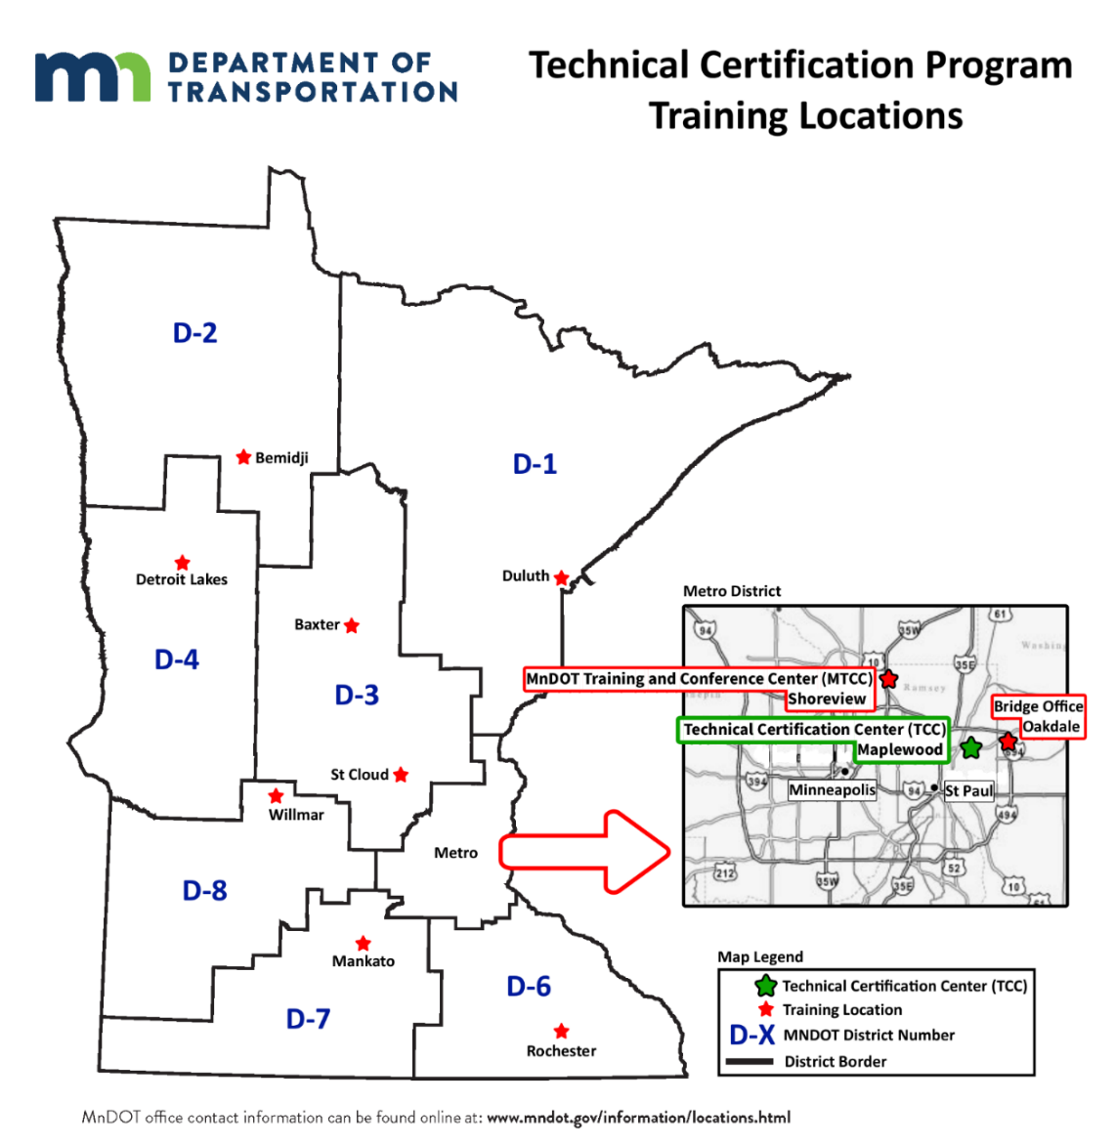

Metro: Technical Certification Center (TCC)  (Front entrance with blue roof)  Office of Materials and Road Research  1400 Gervais Ave  Maplewood, MN 55109  Metro: Maplewood Lab  (Front entrance between flagpoles)  Office of Materials and Road Research  1400 Gervais Ave  Maplewood, MN 55109  District 1: Duluth  1123 Mesaba Ave  Duluth, MN 55811  District 2: Bemidji  3920 US-2  Bemidji, MN 56601  District 3: Baxter  7694 Industrial Park Rd S  Baxter, MN 56425  District 3: St. Cloud  3725 12th St N  St. Cloud, MN 56303 | Metro: MnDOT Training and Conference Center (MTCC)  1900 County Rd I  Shoreview, MN 55126  Bridge Office – Oakdale  3485 Hadley Avenue North  Oakdale, MN 55128  District 4: Detroit Lakes  1000 US-10  Detroit Lakes, MN 56501  District 6: Rochester  2900 48th St NW  Rochester, MN 55901  District 7: Mankato  2151 Bassett Dr  Mankato, MN 56001  District 8: Willmar  2505 Transportation Rd  Willmar, MN 56201

