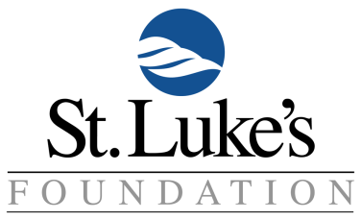

ASPIRUS ST. LUKE’S VOLUNTEER MEMORIAL SCHOLARSHIP - $500

Scholarship criteria:

- Be accepted and presently enrolled in an accredited healthcare program at Lake Superior College, Fond du Lac Tribal and Community College, Minnesota North College – Hibbing Campus, or Northwood Technical College – Ashland or Superior Campus.
- Program must lead to a healthcare career which provides direct patient care.
- Completed one semester of post-secondary academic work in their accredited healthcare program, at one of the schools listed in #1 above, before applying.
- Demonstrate scholastic ability with a GPA of 3.0 in their chosen field of cumulative work.

Please complete the following and return with attachments to St. Luke’s Foundation (Northland Medical Building, 1000 E 1st Street, Suite 102 Duluth, MN 55805) or email this completed application and attachments to ASL-foundation@aspirus.org no later than Friday, April 3, 2026. Contact Mary Matlack, Volunteer Program Administrator at 218-249-5343 or mary.matlack@aspirus.org or Becky Lindberg, Major Gifts Officer at 218-249-5673 or rebecca.lindberg@aspirus.org with any questions.

Full Name (first, middle, last):______________________________________________Date:___________

Address:______________________________________________________
City: _____________________________ State: ____ ZIP: ___________ Phone:_____________________

Email:__________________________________________________________________

Name of Post-Secondary School________________________ Healthcare Program _______________________
Student ID Number _______________________________

ATTACHMENTS:
- Please provide a paragraph describing why you are a good candidate for this scholarship including:
- future plans both professionally and in service to others
- most significant volunteer positions: where you volunteered, your specific role and number of volunteer hours in each position.
- Please attach a copy of your transcript.
- Please attach a written reference from one of the following: a post-secondary instructor in your healthcare field, an employer, or a volunteer coordinator.
-------------------------------------------------------------------------------------------------------------------------------

Volunteer Scholarship Committee Only

Application Reviewed On: Scholarship Awarded: yes no

Comments:

