Name of Student Life Club (include Advisor’s Name), Advisor and/or Student Life Employee Requesting Special Expense funding: (please print)
____________________________________________________________________________________________________________________________________________________________
Please explain why the special expense of an apparel purchase is consistent with the use of Student Club Funds (Student Life Policies): Please add cost center information.
__________________________________________________________________________________________________________________________________________________________________________________________________________________________________________
Please provide the names of the individual club members who will receive apparel being requested for purchase using club funds: (please print)
____________________________________________________________________________________________________________________________________________________________________________________________________________________________________________________________________________________________________________________________________________________________________________________________________________________________________________________________________________________
Total Funds Requested: $__________________
Requestor’s Signature: ____________________________________ Date: ____________
Advisor’s Signature: _______________________________________ Date: ____________
Dean of Students Signature: _______________________________ Date: ____________
Approved apparel items with costs up to $30.00 can be purchased using club funds, all costs above $30.00 will be the responsibility of the individual club members receiving apparel item.
LSC reserves the right to not approve any apparel purchase that does not meet established criteria outlined in the Student Club Apparel Request Form.
When requesting custom apparel items not in stock in the LSC Store, club funds can be used for apparel items with the official name of the LSC Student Club. Student club members can also request to have the individual’s legal name added to the apparel item. Apparel can only be requested to promote the student club and not for any other purpose.
Choose from LSC approved logo options listed below. Only logos listed below will be allowed on club apparel purchased using club funds. Apparel choice must include at least one of the logos listed under A, B, or C.
A. Lake Superior College Logo Options Available,
1. 2.
3. 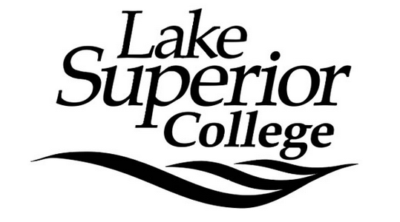 4. 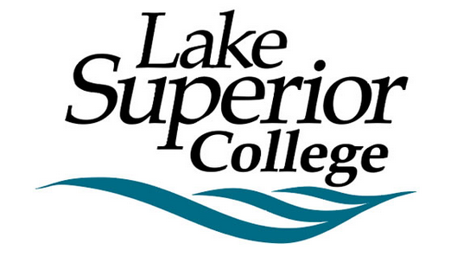
B. Primary IceHawk Logo Options Available: *
1. 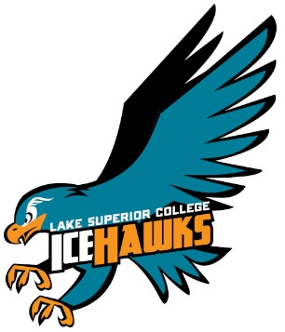 2. 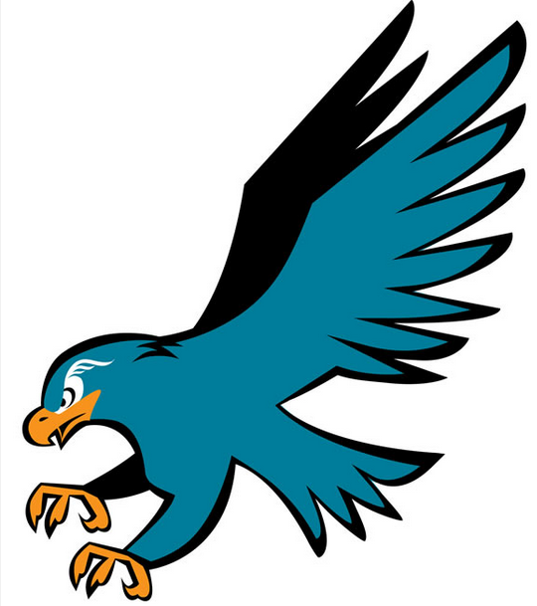

C. Secondary IceHawk Logo Options Available: *
1. 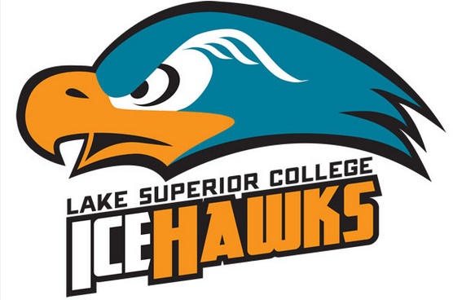 2. 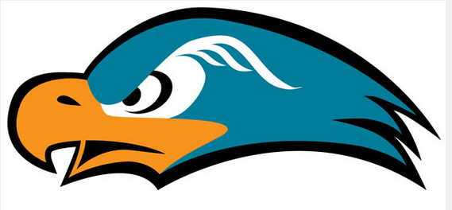
Optional: Students may choose to also have their legal name placed on the apparel item.
To access official LSC Logos in electronic formats please click on the link: https://portal.lsc.edu/home/marketing/campus-logos/
Lake Superior College Apparel Font Color and Typeface Information: *
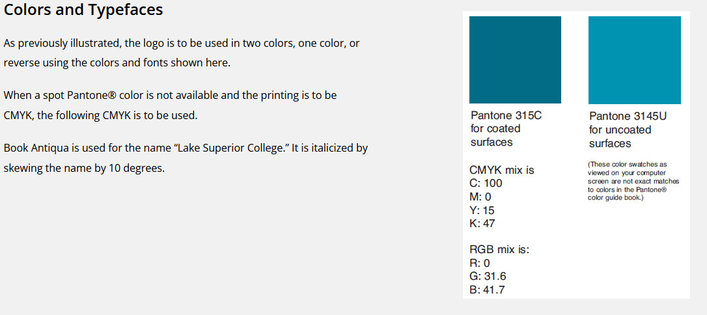
LSC Store Use Only: Please describe quantity, sizes, type, color of apparel, plus logos chosen, and initial.

LSC Store Employee Signature: _______________________

